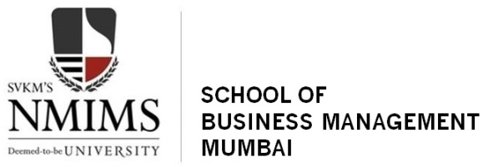

International hrm project report

Studying the HR practices and policies related to the entire employee life cycle in USA-Headquartered organizations- General Electric (GE) & Facebook (FB)

**Submitted By:**

Himani Arora (HR009)

Neeraj Gupta (HR017)

Devashree Trivedi (HR018)

Purva Jain (HR027)

Table of Contents

General Electric

Overview 2

Culture 3

Organizational Chart 4

Employee Life Cycle 4

HR Practices 6

Expatriate Management 10

Facebook

Overview 11

Organization Structure 12

Culture 12

Employee Life-Cycle 13

Facebook’s Expatriate Support System 18

General Electric

Overview

General Electric (GE) is an American [multinational](http://en.wikipedia.org/wiki/Multinational_corporation) [conglomerate](http://en.wikipedia.org/wiki/Conglomerate_(company)) corporation incorporated in [New York](http://en.wikipedia.org/wiki/New_York) and headquartered in [Fairfield, Connecticut](http://en.wikipedia.org/wiki/Fairfield,_Connecticut). The company operates through the following segments: [Energy](http://en.wikipedia.org/wiki/GE_Energy), [Technology Infrastructure](http://en.wikipedia.org/wiki/GE_Technology_Infrastructure), [Capital Finance](http://en.wikipedia.org/wiki/GE_Capital) as well as [Consumer and Industrial](http://en.wikipedia.org/wiki/GE_Home_%26_Business_Solutions)

**Size:** 5000+ Employees **Founded:** 1892 **Type:** Company - Public (GE) **Revenue:** $10+ billion (USD) per year **Competitors:** [Philips Electronics](http://www.glassdoor.com/Overview/Working-at-Philips-Electronics-EI_IE3496.11,30.htm), [Siemens](http://www.glassdoor.com/Overview/Working-at-Siemens-EI_IE3510.11,18.htm), [Citi](http://www.glassdoor.com/Overview/Working-at-Citi-EI_IE8843.11,15.htm)

**Mission:**GE (NYSE: GE) works on things that matter. The best people and the best technologies, taking on the toughest challenges., finding solutions in energy, health and home, transportation and finance. Building, powering, moving and curing the world. Not just imagining, Doing. GE works

**Building** - GE is building the world by providing capital, expertise and infrastructure for a global economy. We build appliances, lighting, and other products that help millions of homes, offices, factories and retail around the world work better.  
  
**Curing** - GE is supplying the healthcare technology that saves nearly 3,000 lives every day. Our focus is on helping medical professionals make an earlier, more accurate diagnosis of disease and then better equipping them to treat it.  
  
**Moving** - From airlines on the world’s largest and most efficient jet engine to freight using the most advanced locomotives and signaling systems to helicopter engines that perform life-saving rescue mission. If there is a better way to move people and goods, GE is behind it.  
  
**Powering**- GE powers the world with the cleanest, most advanced technologies and energy solutions. From FlexEfﬁciency power, to smart grids to engines that run on organic waste, we currently help to deliver a quarter of the world’s electricity.

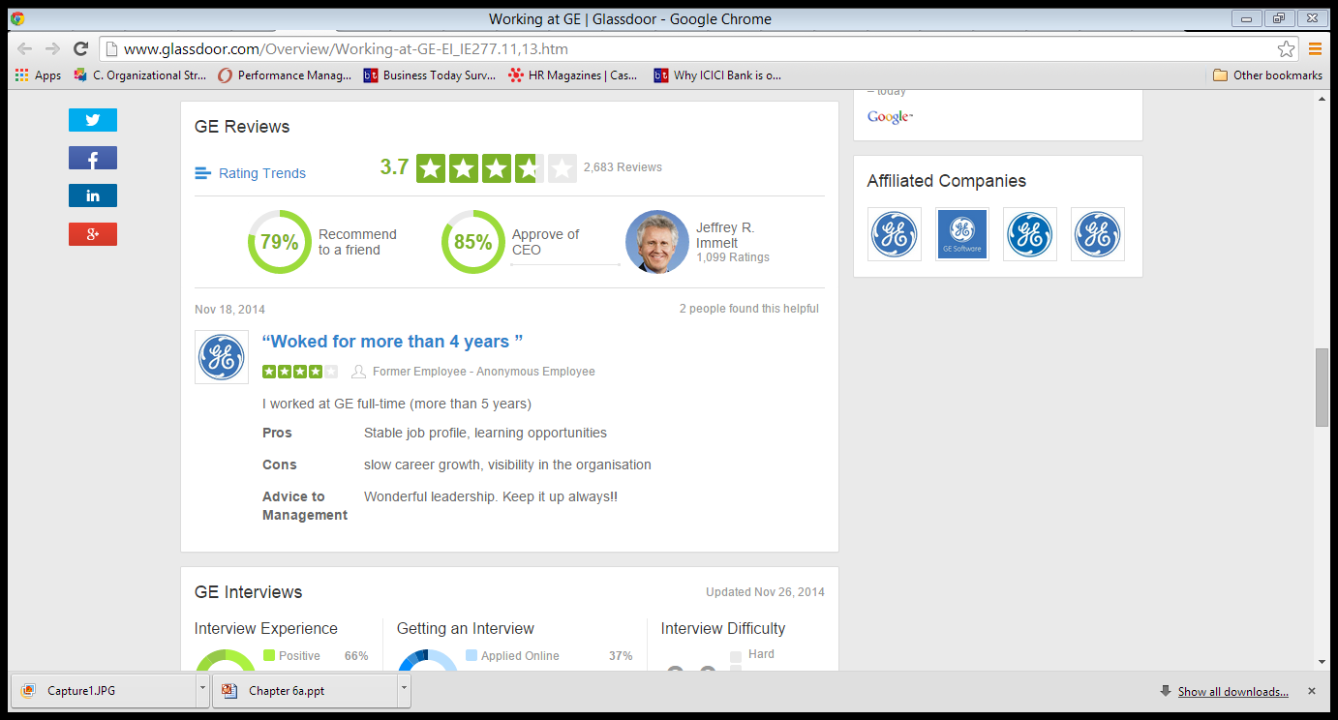

Culture

# Life at GE

### Innovation

From the outset, innovation has been part of GE’s DNA. That means being surrounded by bright, interesting people working together on new and exciting projects. It means trying to find new and better ways of doing things. And it means enjoying a career with extraordinary opportunities and enormous potential.

### Leadership & Training

We hire exceptional people and invest in their growth. GE has a culture of continuous learning, thoughtfully designed to enable employees to grow their personal capabilities and reach their full potential. We invest in your education, provide access to experienced colleagues and give you the opportunities to work with intelligent, dedicated people, challenge yourself, and grow.

### Global Business

We do business in over 160 countries, giving our employees a literal world of experience. Your opportunities at GE are defined, in part, by the emerging needs of our businesses, customers and clients all around the world, because we go where the opportunities take us. A career at GE offers you access to some of the most exciting and dynamic challenges of your lifetime.

### Integrity

Integrity is an essential component of life at GE. It is how we conduct ourselves and how we do business. It is non-negotiable. While some businesses prize results over ethics, we value both. At GE we believe that how you do something is as important as what you do. We provide you with the training and opportunities to enjoy a successful career you can be proud of, now and for the rest of your life.

### Citizenship

GE's approach to citizenship is a full-time commitment with the same goals, strategies and accountabilities that drive any other part of our business. GE applies its long-standing spirit of innovation and unique set of capabilities to take on tough challenges in our communities.

Organizational Chart

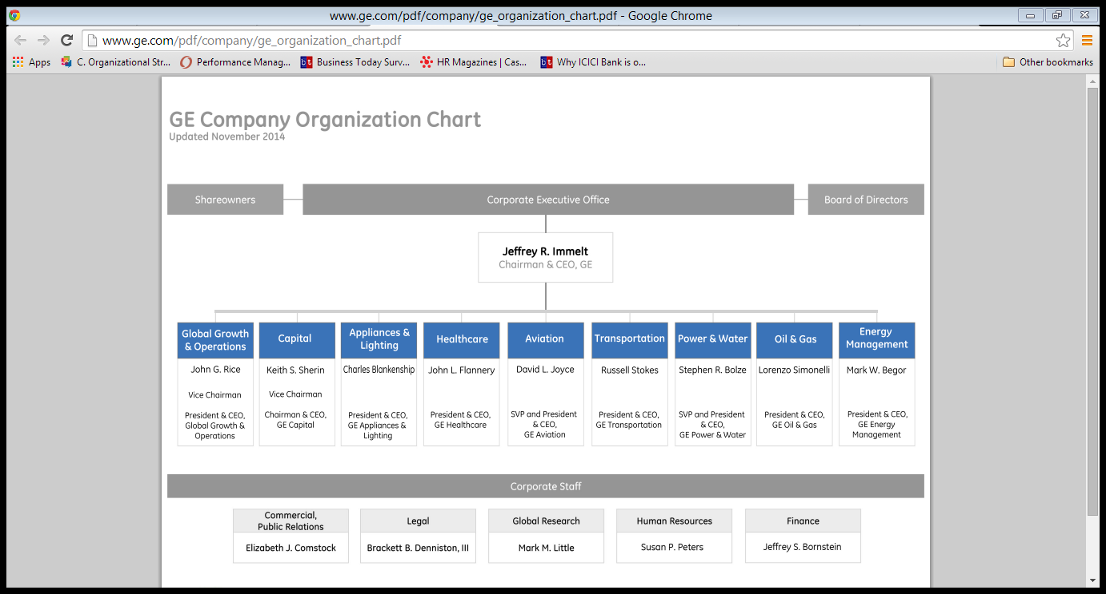

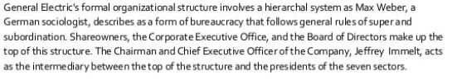

Employee Life Cycle

**Hiring**

# University Relations

## [On-Campus Recruiting](http://www.ge.com/in/university-students/campus-recruitment)

On-campus recruiting is a great opportunity for applying to GE. GE recruits Management and Engineering students through a rigorous on-campus recruiting process.

The Experienced Commercial Leadership Program (ECLP) is a key recruiting initiative that hires a huge chunk of MBA graduates each year

### Program Structure

Specific to the Experienced Commercial Leadership Program (ECLP), candidates are hired into one of the nine businesses based on candidate preference and business need and complete all three rotations within that business.

Participants complete three 8-month rotations in sales and/or marketing functions within their hiring business and are expected to be geographically mobile.

* Examples of marketing rotations: Strategic marketing, market analysis, market segmentation, product management, new product introduction (NPI), brand management, advertising
* Examples of sales rotations: Sales Force Effectiveness (SFE) implementation, business development, national account management, sales operations management

Although each participant's rotations are different over the two years, the standard curriculum and the power of the ECLP network drives consistency in the participants' experience.

### Recruiting & Hiring Process

For US candidates only: Recruiting Process and Timeline. (This process & timeline varies by region outside of the US.)

|  |  |
| --- | --- |
| Event | General Timeline |
| Campus presentation | September (varies by school) |
| Resume drop | September/October (varies by school) |
| First round interviews on campus or by phone | October (varies by school) |
| Second round interviews (off campus) | Early November |
| Decisions made/offers extended | Mid November |
| Program start date | Mid July of the following year (varies by business) |

## [Internship Opportunities](http://www.ge.com/in/university-students/internship-opportunities)

At General Electric (GE), internships are often the gateway to full-time positions, and the company has created a formal strategy to ensure its pool of young talent remains full. The company has identified 45 executive schools in the U.S. where it recruits about 70 percent of its hires. Outside the U.S. GE has identified approximately 60 schools where it builds the brand and attracts candidates.

Internships at GE are aimed at providing the best-in-class learning experience, fuelling both your personal and professional development. Through these internships you get an opportunity to work on ‘live’ assignments, gain hands-on industry exposure, engage with senior leaders within the business, network with colleagues and set yourself up for success.

## [Campus Connect](http://www.ge.com/in/university-students/campus-connect)

GE hosts and sponsors many events across premier B-Schools. This is an opportunity for students to interact with Senior GE Leaders and know the company better. GE proactively reaches out to institutes that we wish to collaborate with. Watch out this space for updates on our campus events.

HR Practices

## Employee Engagement

The GE culture is unique and powerful. With over 300,000 employees working around the globe across six diverse businesses, the GE culture is ever prominent and prevalent.

The key is consistent communication and employee engagement.

*“Employee engagement first. It goes without saying that no company, small or large, can win over the long run without energized employees who believe in the mission and understand how to achieve it. That's why you need to take the measure of employee engagement....”* - **Jack Welch, Former CEO, GE**

This speaks volumes on how much the company emphasises on employee engagement. Here are the nine questions that GE considers to actively engage with its employees:

* Are employees working with the best people in the field?
* Does the company offer competitive compensation?
* Is the company a growing market leader?
* Does the company provide sufficient recognition and career development opportunities for employees?
* Are employees working in a supportive environment and able to maintain their life style?
* Does the company offer prestigious work to employees (e.g. business trips and networking with clients)?
* Are employees working for a well-known brand (the company itself)?
* Is the company the “right fit” for employees?

## Employee Development

Creating leaders is one area where GE's reputation remains unparalleled. Year after year the world sees it as the gold standard for talent. General Electric’s leadership training alumni include the CEOs of 26 of the largest companies in the United States. GE does not use an ROI metric to evaluate its leadership development programs, but the market does. A Harvard Business School study of 20 GE-trained executives poached by other companies between 1989 and 2001 found that 17 produced an instant spike in the hiring company’s stock price, with an average gain of $1.1 billion across the group.

Although GE’s best practices for leadership development are widely studied and emulated by other companies, the results are rarely duplicated. CEO Jeffrey Immelt spends 30 per cent of his time on leadership development. HR owns the global learning organization, including the entire leadership development curriculum.

GE runs with 197 corporate officers worldwide who lead the large revenue-generating businesses or critical functional groups. Most of these have spent at least 12 months in training and professional development. In 2006, GE launched its Leadership, Innovation and Growth course for senior business leaders worldwide.

Participants are selected through the annual "Session C" process, a leadership analysis that includes a specialized performance review. GE’s annual Session-C process — an organization-wide talent review assesses the performance of individuals and business units all the way up to the CEO. Session C entails employees assessing their own accomplishments, strengths/development needs and career aspirations, followed by manager assessments and review. During this process, managers give their people brutally candid feedback based on achievement of stretch objectives and demonstration of company values. To quantify their performance, employees are then placed on a 9×9 grid reflecting these two dimensions. Human resources owns the Session C agenda, but the business leaders control and conduct the actual reviews.

With half of its revenues and employees outside the U.S., GE is now focusing on leadership development abroad. A team from Crotonville, GE’s corporate training facility in New York, is permanently based in China to serve Asia, and another team is based in Europe.

## Performance Management

Jack Welch, retired Chief Executive Officer of General Electric (GE), is most often associated with forced ranking, since GE used this performance management tool to eliminate the bottom ten per cent of performers each year. Jack Welch's vitality model has been described as a "20-70-10" system. The "top 20" per cent of the workforce is most productive, and 70% (the "vital 70") work adequately. The other 10% ("bottom 10") are non-producers and should be fired. Rank-and-yank advocates credit Welch's rank-and-yank system with a 28-fold increase in earnings (and a 5-fold increase in revenue) at GE between 1981 and 2001.

However, since Jack Welch's departure from the company, less emphasis has been placed on eliminating the bottom 10% and more emphasis placed on team-building. Managers dedicate time to prepare for a detailed discussion of a direct report’s performance and values, strengths, development needs, and development plans. Individual appraisals are considered enormous opportunities for the candid, constructive conversations that employees deserve.

## GE India’s Unified Reward Philosophy

**Challenge**

Create a unifying reward framework to attract and retain top performers, and provide employees with a broader, more holistic view of compensation, benefits and intangible elements

**Approach**

Analysed reward programs, conducted in-depth interviews with business leaders, created a new reward framework and launched several workforce programs

**Result**

Employees have responded very favourably to new programs; leaders are speaking the same reward language, and employees better understand the employee value proposition

To enhance its growth prospects in India, GE implemented a new organizational structure for GE India. Different India-based business units — each with its own reward structure — were consolidated into one. The change made GE India not only more competitive, but also better able to attract the talent it needs.

The company turned to Towers Watson for help. The Towers Watson team began by analysing GE India’s reward programs and HR metrics. The consultants thoroughly reviewed base pay, incentives, benefits, recognition programs and training opportunities. They also examined the organization’s workforce demographics, including each employee’s age, length of service, job functions and management level. Next, the team   conducted one-on-one interviews with more than 30 executives, business leaders and HR heads to explore each business unit’s reward framework.  It was learned that most GE India employees wanted more flexible benefit offerings and user-friendly online tools for electing and managing their benefits. They also asked for variable pay tied to individual performance. In response, the HR drafted the organization’s new reward framework. The framework guided GE India leaders as they developed several new workforce programs. They launched a flexible benefits program and an online portal for the senior employees. They could choose from among medical insurance, life insurance, annual leave and other benefits. Employees were given a basic level of insurance coverage, but could opt for a different level that better suited their needs.

Along with these efforts, HR harmonized the organization’s compensation program and gave leaders more control over compensation decisions. To boost employee engagement and clarify the process, the HR team developed training sessions and other tools.

Another new program receiving good reviews is the Grow India Plan (GIP), a variable pay program that tied incentives and rewards to business priorities and will stimulate individual performance to drive business growth.

## Succession Planning

GE is well known for its exhaustive and systematic approach to identifying and cultivating its business leaders. Succession planning is an integral part of the business continuity plan throughout GE. And leaders help grow other leaders, and are expected to aid in the cultivation of their own replacements.

Ever business at GE is responsible for having succession plans in place for key leadership roles. Succession planning goes hand in hand with leadership development, a cornerstone of GE’s culture. The **key steps** along that path are:

**Assessment of key positions:** Leaders take an inventory of the key positions needed to achieve their business goals and assess the competencies and experiences needed for each critical position. Leadership positions are assessed for both their business impact and retention risk, and the most high-risk, high-impact roles are the primary focus of their succession planning.

**Identification of key talent:** Using leadership’s assessment of their performance, employees are evaluated for their potential for advancement.

**Preparation of key talent:** For each person on the succession radar screen, managers identify primary development needs, focusing on what they require in order to be ready for the next level. A specific development plan is prepared, detailing how the organization will help those people develop over the next year.

**Development monitoring and review:** The system tracks the progress of employees on an individual basis and the on-going organizational reviews keep the succession pipeline current and full.

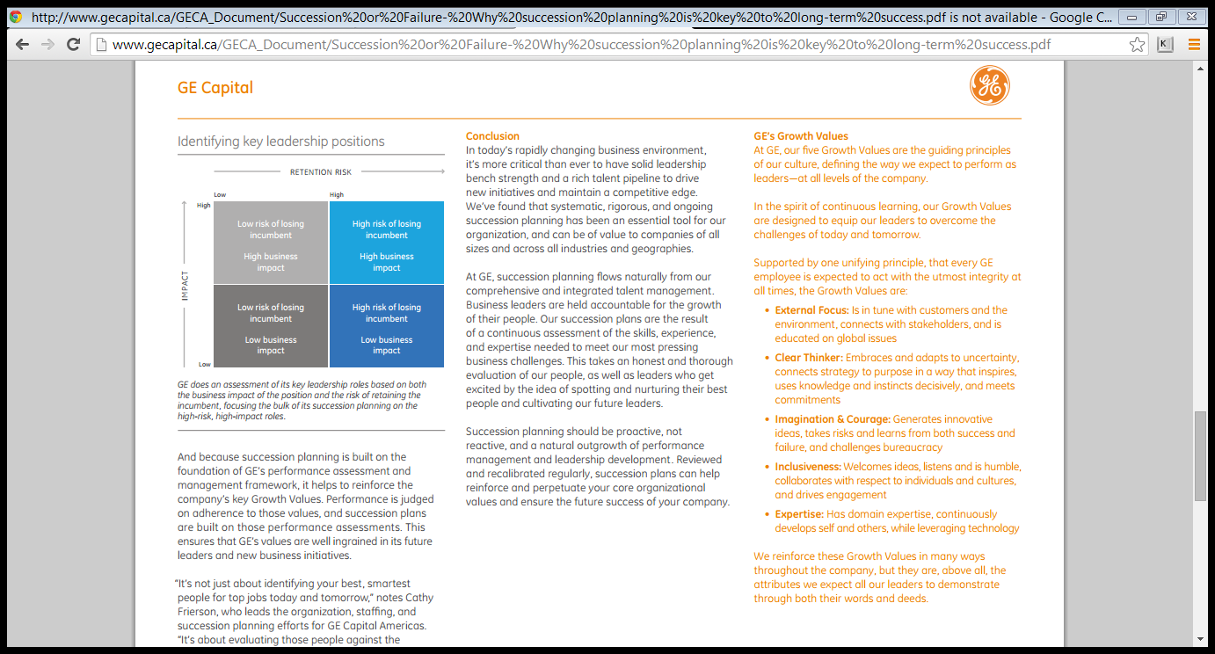

At GE, succession planning is not a one-off initiative to fill a particular leadership post, but an on-going assessment of their talent pipeline and the career paths of their high-potential business leaders. As a result, it is pervasive throughout our organization and is an essential element of their performance-driven culture.

Expatriate Management

Expatriate managers for GE in markets such as India and China are supposed to look for their successors locally. The approach reflects that: local trainers adapt courses to local sensibilities, while managers in the classes are encouraged to feed in their regional perspective. The outcome is: Development of leaders with global perspectives.

Facebook

Overview

Facebook is an online social networking service headquartered in Menlo Park, California. Its website was launched on February 4, 2004, by Mark Zuckerberg with his college roommates and fellow Harvard University students Eduardo Saverin, Andrew McCollum, Dustin Moskovitz and Chris Hughes. The founders had initially limited the website's membership to Harvard students, but later expanded it to colleges in the Boston area, the Ivy League, and Stanford University. It gradually added support for students at various other universities and later to high-school students. Facebook now allows anyone who claims to be at least 13 years old to become a registered user of the website, Its name comes from a colloquialism for the directory given to it by American universities students.

**Employees**

8,348 employees as of September 30, 2014

**Statistics**

* 864 million daily active users on average for September 2014
* 703 million mobile daily active users on average for September 2014
* 1.35 billion monthly active users as of September 30, 2014
* 1.12 billion mobile monthly active users as of September 30, 2014
* Approximately 82.2% of our daily active users are outside the US and Canada

**Offices**

US offices

Atlanta, Austin, Boston, Chicago, Dallas, Detroit, Denver, Los Angeles, Menlo Park, Miami, New York, Reno, Seattle, Washington D.C.

International offices

Amsterdam, Auckland, Berlin, Brasilia, Brussels, Buenos Aires, Dubai, Dublin, Gurgaon, Hamburg, Hong Kong, Hyderabad, Jakarta, Karlsruhe, Kuala Lumpur, London, Madrid, Melbourne, Mexico City, Milan, Montreal, Mumbai, New Delhi, Paris, Sao Paulo, Seoul, Singapore, Stockholm, Sydney, Tel Aviv, Tokyo, Toronto, Vancouver, Warsaw

Data Centers

Altoona, Forest City, Lulea, and Prineville, with a co-located facility in Ashburn

**Mission**

Facebook’s mission is to give people the power to share and make the world more open and connected. People use Facebook to stay connected with friends and family, to discover what’s going on in the world, and to share and express what matters to them.

Organization Structure

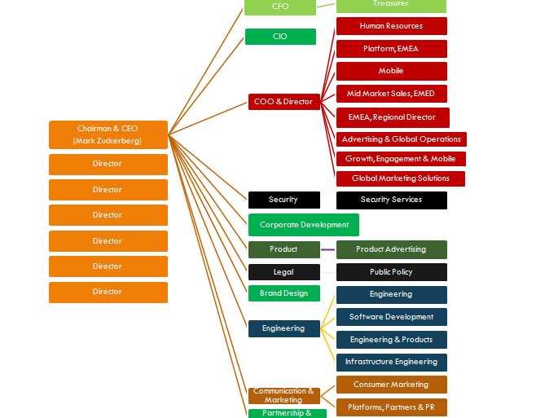

Culture

Facebook is defined by its hacker culture - an environment that rewards creative problem solving and rapid decision making. They encourage people to be bold. Its open culture keeps everyone informed and allows people to move around and solve the problems they care about most. They work in small teams and move fast to develop new products, constantly iterating and improving. The phrase “this journey is 1% finished” is posted on their walls, reminding them that they’ve only begun to fulfil their mission to make the world more open and connected.

**Its management approach focuses on speed and risk-taking**

1. **Speed is essential, so “move fast and break things.”** — Facebook isn’t unique in that speed is critical to being first to market. At Facebook, management proactively encourages employees to move incredibly fast, even though it will obviously result in some failures. Many firms have slogans, but Facebook goes to the extreme of painting corporate culture slogans larger-than-life on walls throughout the facility, and one of Facebook’s most prominent slogans is “Move fast and break things.” The concept follows the CEO’s idea that “If you never break anything, you’re probably not moving fast enough.” At Facebook, “We’re less afraid of making mistakes than we are of losing opportunities.” Another slogan emphasizes the importance of getting things finished and implemented rather than waiting until they are perfect, and that slogan is … “Done is better than perfect.”
2. **“Be Bold”** **and take risks** — most corporate cultures are risk averse, and in many cases, to the point where everyone is afraid to fail even once. Facebook is the complete opposite; its culture encourages bold decision-making and risk-taking. Its approach is illustrated by these less-than-subtle slogans: “The riskiest thing is to take no risks,” and “We encourage everyone to make bold decisions, even if that means being wrong some of the time,” and “In a world that’s changing so quickly, you’re guaranteed to fail if you don’t take any risks.” In a world where going first and being innovative is of course full of huge risks, you have no choice but to find a way to convince your employees to avoid the more common and natural conservative approach.
3. **The strong culture enabled a 180-degree shift in direction** — the real strength of any company culture is its ability to change and shift the focus of its employees when the market requires it. The Facebook product has always been a website-housed product that was accessed through a PC. However you have to credit the CEO and the company culture for quickly realizing that the smart phone would eventually become the dominant platform. And in a period of less than two years, the company made a successful shift so that its product is now primarily accessed through the mobile platform and the smart phone. To make the 180-degree shift even more impressive, the advertising revenue from the mobile platform is now becoming a larger part of Facebook’s profit. The culture has also survived the loss of significant revenue from the decreased popularity of Facebook-based games from Zynga.

Employee Life-Cycle

**Hiring at Facebook**

1. **Acqui-hiring is a unique corporate practice**–Acqui-hiring is where you acquire (usually smaller firms) primarily for their talent, rather than for their products or customers. Until its recent Instagram purchase, almost all of Facebook’s acquisitions had as a primary goal to acquire technical talent. The added advantage of this practice is that you get a whole “intact team” that if integrated correctly, can be productive almost immediately. “Acquiring the firm” may be the only way to capture “start-up/hacker mentality” talent that wouldn’t on their own ever consider applying for a job at a large corporation, even one as exciting as Facebook.
2. **Obviously it can’t require a college degree**– because it’s obviously successful CEO is a college dropout, it would be glaringly inconsistent and perhaps a little embarrassing to require a new hire to have a college degree. As one of the recruiters put it, “It would be weird for us to require a college degree.” So instead, its recruiting focus is “If you can build awesome stuff and have big impact, that’s all we’re really looking for.” Not requiring a completed degree gives it a chance to land top talent long before other firms, which must wait until after they graduate.
3. **Contest-based recruiting reveals what a prospect can build**– Facebook, like many other Silicon Valley firms, relies heavily on Internet-based technical contests to find hidden or “non-obvious” talent from around the world. These relatively inexpensive contests have simple names like “The Facebook Hacker Cup” but they allow the firm to find people based on the problems they can solve, and what you can build is a major corporate focus. Because contestants are initially anonymous, the winners who are targeted for recruiting are selected because of their work and not as a result of their degrees, experience, gender, or where they reside. Facebook also recruits at algorithm coding contests sponsored by others including TopCoder and Kaggle.
4. **Hackathon college recruiting**– each year Facebook visits more than a dozen college campuses and while there, challenges self-selected teams to come up with solutions to real technical problems. The finalists are brought to the Facebook headquarters for “Camp Hackathon,” where their solutions are judged and the winners get a small prize and an offer of a summer internship. The students get to keep their ideas in case they want to develop their own start-up around it.
5. **It’s CEO as its chief recruiter** — most organizations dream of having its CEO occasionally involved in recruiting but Mark Zuckerberg takes it to the next level. He assumes the role of chief recruiter by periodically speaking publicly about the firm and by visiting college campuses in order to directly attract potential recruits from among faculty and students.
6. **Employee referral “Ninja Hunts**” — Facebook, like most other Silicon Valley firms, relies heavily on employee referrals to identify top recruits. One of its creative approaches for generating names are called “Ninja Hunts,” where recruiters typically ask a gathered group of employees to think about all their friends to see if some of them would be great engineers for Facebook (where Ninja is their name for an exceptional engineer).

**On-boarding and Internal Movement**

1. **Extended six-week boot camp on-boarding with a choice**– most corporate on-boarding is a relatively simple and often boring one day “form filling out” exercise (Facebook instead provides the needed paperwork to the employee before they start). Its approach is unique because it is extended over an industry-leading six weeks. And during that time, rather than watching videos and hearing lectures, employees actually work on teams that spend their time working on multiple real projects. And to demonstrate its trust in new hires, during this time boot campers have full access to the complete computer code behind Facebook. Each employee is assigned a mentor. But the most powerful part of the on-boarding is that at the end of the process, each employee is asked, “Which team and project within Facebook would you like to join?” This is powerful because when you apply for a job, you really have no way of knowing which team or project would be a best fit for you.
2. **Hackamonth self-directed internal movement**– at most organizations, getting approval to move to a new job is a complex often political process where the employee has little control. However Facebook’s Hackamonth process is the opposite because it is a self-directed internal movement process. It allows employees who have worked on a project for a year to select their own next project team and after working with them for a month, if they like it, they can stay.

**Employee Engagement**

1. **Free ice cream and cookies is a life-changing experience**– Google is justifiably famous for publicizing free gourmet food, but Facebook wins the award hands down for the most compelling food. With a relatively young and healthy employee population that doesn’t have to overly worry about its weight, what could be more compelling than a free ice cream store and bakery? A dozen varieties of ice cream, low-fat yogurt, milkshakes, sundaes, as well as cakes, pies, and the absolutely essential cookies, all unlimited and for free.
2. **Free barbecue** - Facebook’s open-pit barbecue is particularly compelling because it is centrally located, and as a result, the smoke from the barbecue waffles throughout the campus making employees think of barbecue. You simply can’t miss it. Of course the barbecue is free but the best feature is that the BBQ shack is in the middle of an open courtyard, where employees can collaborate while in line and then sit in the California sun and eat on picnic tables and chairs.
3. **A global array of food keeps employees on campus**– because it’s 3,000+ employee population in the Headquarter includes a large number of younger people from all over the world, it makes sense that it offers food day and night that fits every “global fast food group.” Being in California, it of course also offers health food including a salad bar, a juice bar, and sushi, as well as vegetarian and vegan options. Employees clearly take advantage of the free food because its roughly 2,400 employees at headquarters eat an average of 7,200 meals a day. The Facebook Culinary Team accepts food requests from employees and it lets employees know what’s on the menu, using of course a Facebook page.
4. **Happy Hour every Friday**– one of the features that seem to startle most corporate people outside of the Silicon Valley is the availability of alcohol at Silicon Valley firms. At Facebook it is available on Friday happy hours and during employee-generated special events. A reason for allowing it at firms is that management simply can’t be credible when it says that it “trusts its employees” if it doesn’t trust its employees to be reasonable in the use of alcohol.

**Economic rewards and employee benefits**

1. **Facebook offers unlimited sick days**– most firms would never even consider offering unlimited sick days, but if your work is truly exciting, your teammates count on you, and you are rewarded for performance, there are few who want to miss much work for frivolous reasons. There are also few better ways to demonstrate your trust in your employees than to offer them unlimited sick days. Facebook also offers 21 days of paid time off each year (essentially a month off) for even new employees.
2. **Amazing benefits for new parents**– Facebook, like most tech firms, struggles to hire and keep women engineers. So it offers close-in reserved parking spaces for those who are pregnant. It also offers “four months paid parental leave for both spouses, reimbursement for some day-care and adoption fees, and $4,000 “baby cash” for a new arrival.
3. **Rewards are based on performance**– the goal is for employee rewards to be differentiated based on performance results and from data from its comprehensive co-worker feedback process. One internal source estimates that the reward differential between a bottom and top performer at the same level can be up to 300 percent. Nothing sends a clearer message to employees that performance matters (over status and tenure) than a large percentage differential between top and average performer rewards.
4. **An opportunity for wealth** — although the firm appears to offer competitive salaries, the prime economic incentive are Restricted Stock Units, which keep employees focused on producing business results. And that business results focus also encourages cooperation and sharing with among employees. Everyone seems to agree that employees get generous RSUs as part of their regular pay package and as bonuses. Obviously many employees got rich as a result of the IPO; however, the opportunity for wealth still exists because the stock now exceeds the IPO level and its value has been growing at a rapid rate.
5. **It encouraged workers to drop by at any time** — in 2008-09, Facebook paid its employees $600 each month extra for living within a mile of Facebook headquarters. The goal was to subtly encourage employees to live close by so that it was easy for them to casually drop in for free food but also for extra work and collaboration. The unintended impact on dramatically raising rents around its Palo Alto headquarters was one reason for eliminating this practice in 2009.

**Performance Management**

Facebook has a performance management review every six months (starting in January and July). They call it the Performance Summary Cycle. There is a two week period where employees solicit peer feedback (usually 3-5 peer reviews), write a self assessment, and write a manager assessment. Managers then read all the peer feedback and the self assessment and determine a "Performance Assessment" or rating of the employee's performance over the last six months as well as whether or not it is the right time to promote the employee.   
  
Then there is a (roughly) two week period of calibration where managers meet to look at the assessments of everyone on their team and ensure that people are rated correctly relative to their peers. Facebook has seven performance assessments as well as a guideline for what % of employees should be at each level, however it is explicitly not a forced curve, particularly for small teams.The curve exists to ensure that extraordinary performance is rewarded (I believe the distribution is such that only 2% or less of employees are given the highest rating every cycle) and that if hard conversations need to happen, they happen.

Calibration happens at the team level and at the senior management level (Mark, Sheryl, and all of their direct reports look at the numbers for the whole company, lists of the highest performers, lists of the lowest performers, etc). Performance Assessments are final and they are used to determine compensation like raises, bonuses, and additional equity grants. Facebook gives out raises and additional equity once a year but they do promotions and bonuses twice a year. Compensation at Facebook is almost entirely formulaic with multipliers (based on the Performance Assessment) for bonuses, raises, and additional equity grants.  
  
At the end of the cycle, managers have performance conversations with employees where they summarize the feedback (in person and in writing) and give them a compensation letter that includes their rating, bonus, and any additional information. In recent years, the whole cycle has taken about six weeks, which is pretty impressive for a company of ~7,000.

Facebook’s Expatriate Support System

